FI03 -

Functionality
Bank Master Records are stored in the bank directory. Their details are stored also in Customer / Vendor Master Data and are used by payment program to prepare payment documents. You can create new Bank Master Record using transaction FI01 or you during maintaining Cust. / Vendor Master Data.

Scenario
You want to display bank master.

Requirements
Created previously bank master record.

Menu Path | Accounting → Financial Accounting → Banks → Master Data → Bank Master Record → FI03 – Display.
Transaction Code | FI03

1. Double click on FI03 – Display.

Display bank : Initial screen

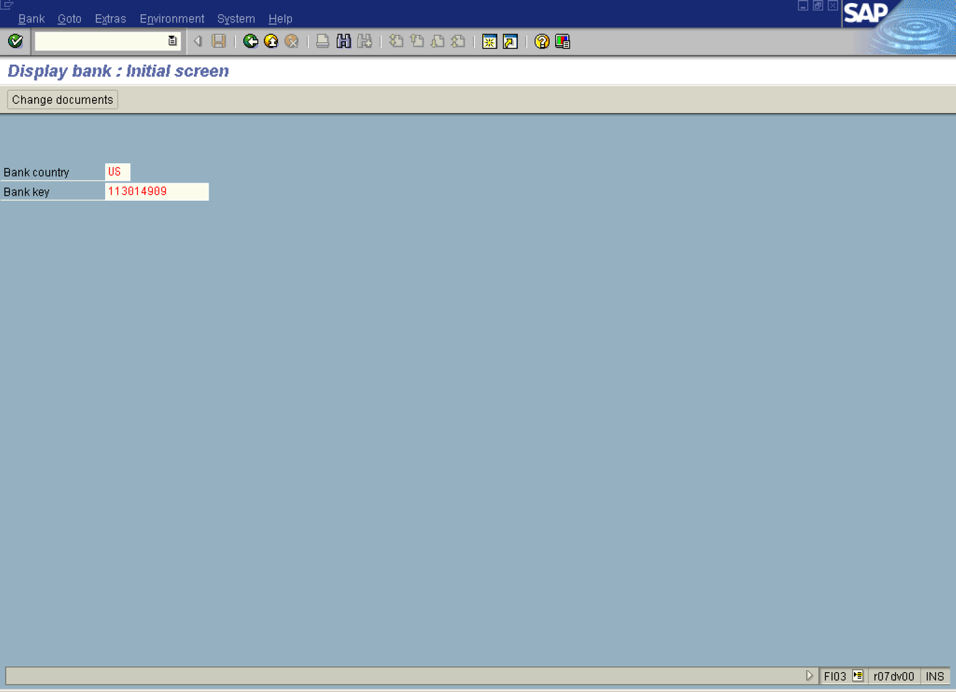

2. First you need to select the bank master you want display. Enter bank country (e.g. US) and press tab to switch to the field Bank key. Press [F4] or click the button in the Bank key field.
3. The system will display a search screen. Enter your search criteria or just click Enter Button :

Bank Address

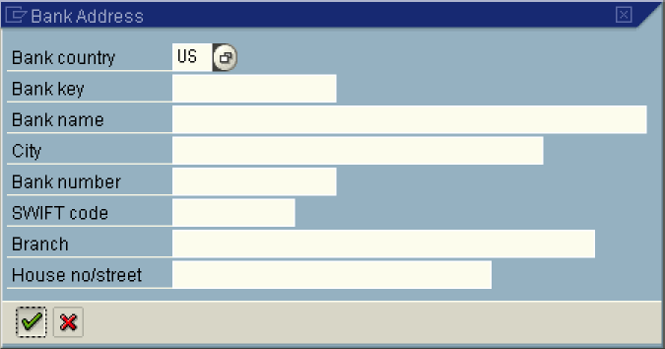

4. The system will display a list of Bank Masters that fulfill your search criteria:

Bank data (1) 4 Entries found

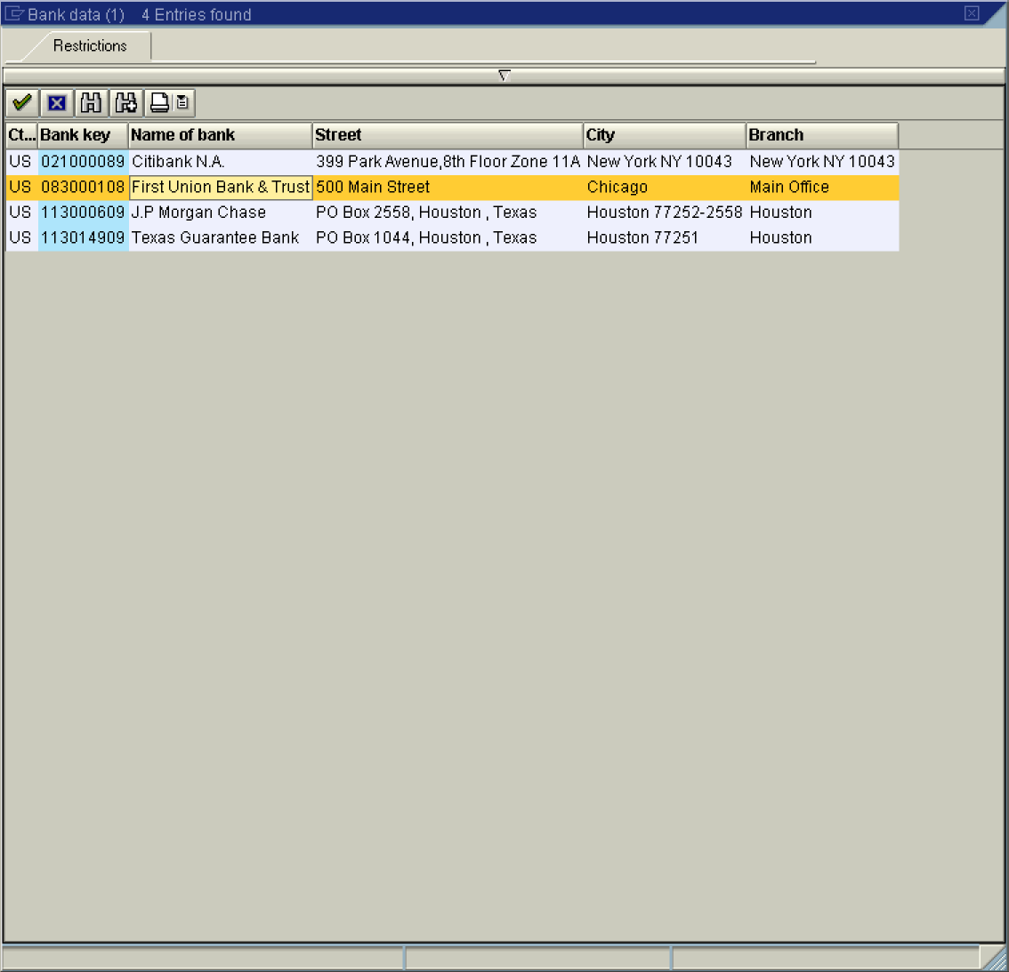

5. Select the required bank master from the list – double click on the field Name of Bank (e.g. US - 083000108 - First Union Bank & Trust).

6. The selected bank master number will be entered to the field Bank key:

Display bank : Initial screen

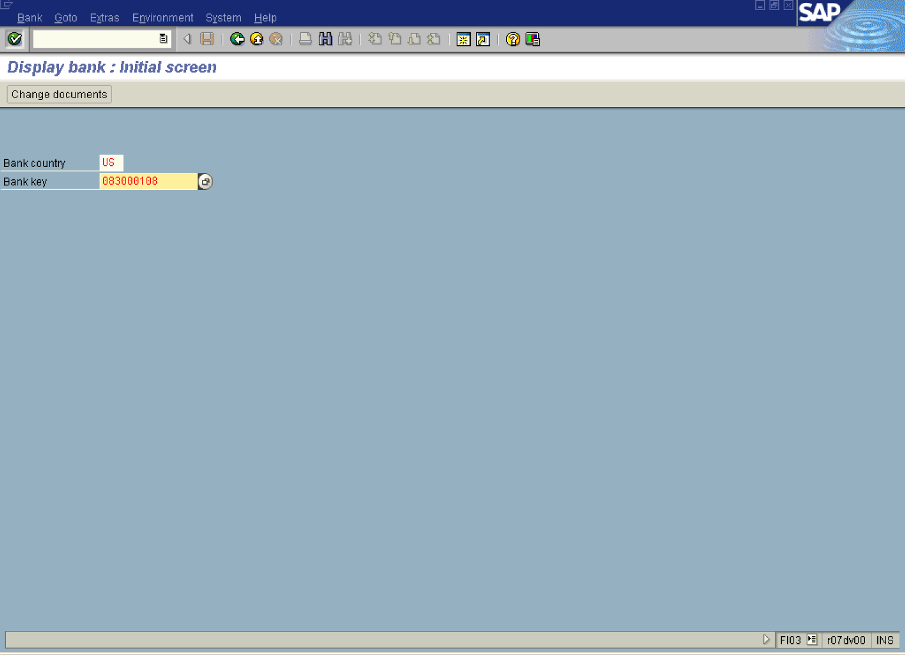

7. Click Enter Button to confirm your entries.

Display bank: Detail screen

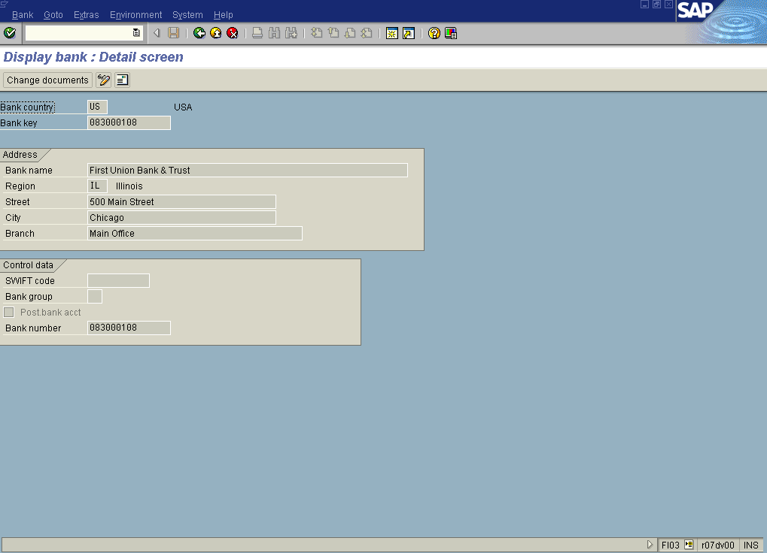

8. The system displays bank details.

Tip: On this screen the following buttons are available: Change documents and Edit. You can use them to display bank master changes or edit bank master respectively.

